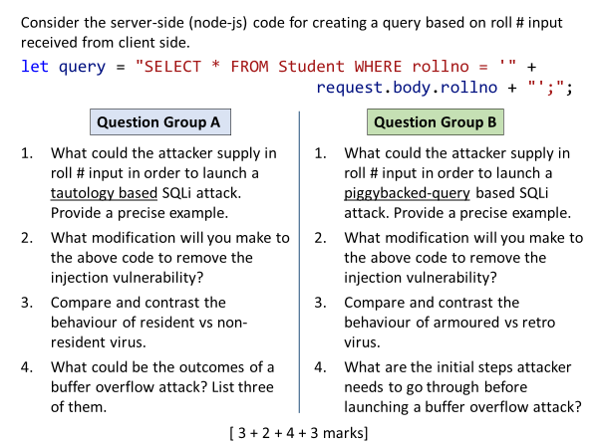

**Group A**

Q1

**' OR 1=1; --**

Need a single quote for string termination, OR with always-true condition, sql comment mark

Q2

Use a SQL prepared statement. OR

Before inserting rollno input into query, process it input through a sanitization (encoding/escaping) function.

Q3

Resident virus stays in memory, even after the host program has been terminated. It infects other processes in memory.

Non-resident directly attacks the files on hard disk. It searches for infectable files throughout the disk, infect them and then exist from memory.

Q4

*Any 3*

Program data corruption

Program termination due to memory access violation

unexpected transfer of control

control hijacking by attacker

**Group B**

Q1

**'; DROP TABLE Student; --**

Need a single quote for string termination, semicolon for query termination, any extra query after that.

Q2

Use a SQL prepared statement. OR

Before inserting rollno input into query, process it input through a sanitization (encoding/escaping) function.

Q3

Armored virus is designed to be undetectable in static analysis (as packer, or cavity malware) and dynamic analysis (via debugging and VM detection techniques).

Retro virus is designed to block or disable the functionality of security software like antivirus, firewalls etc.

Q4

Identify a vulnerability in the target application using inspection, tracing execution, fuzzing tools

Understand how buffer is stored in memory

Figure out the input data that will cause BO